**LAWYER ON A CLICK**

A Project Report submitted in partial fulfillment of the

Requirements for the award of the degree of

BACHELOR OF TECHNOLOGY

In

COMPUTER SCIENCE AND ENGINEERING

With IBM specialization in BANKING, FINANCIAL SERVICS AND INSURANCE

Submitted by

APURV SRIVASTAVA (Enroll No. R133215006)

ASHU (Enroll. No. R133215009)

Under the guidance of

Dr. MONIT KAPOOR

Association Department Head of Cybernetics

SOE



**SCHOOL OF COMPUTER SCIENCE**

**COLLEGE OF ENGINEERING STUDIES**

UNIVERSITY OF PETROLEUM & ENERGY STUDIES

Bidholi Campus, Energy Acres, Dehradun – 248007.

**December - 2017**

**DECLARATION**

I hereby declare that this submission is my own and that, to the best of my knowledge and belief, it contains no material previously published or written by another person nor material which has been accepted for the award of any other Degree or Diploma of the University or other Institute of Higher learning, except where due acknowledgement has been made in the text.

**APURV SRIVASTAVA (Enroll No. R133215006)**

**ASHU(Enroll No. R133215009)**

**CERTIFICATE**

This is to certify that the project titled LAWYER ON A CLICK submitted by APURV SRIVATSVA (Enroll. No. R133215006), ASHU (Enroll. No. R133215009) to the University of Petroleum & Energy Studies, for the award of the degree of BACHELOR OF TECHNOLOGY in COMPUTER SCIENCE AND ENGINEERING is a bonafide record of project work carried out by them under my supervision and guidance. The content of the project, in full or parts have not been submitted to any other Institute or University for the award of any other degree or diploma.

Date: __________________

Dr. MONIT KAPOOR HOD DR T.PSINGH

Associative Head Dept. of Analytics\SOE (Department of cybernetics)

**ACKNOWLEDGEMENT**

We wish to express our deep gratitude to our guide **Dr. Monit Kapoor**, for all advice,

encouragement and constant support he has given us throughout our project work. This work would not have been possible without his support and valuable suggestions.

We sincerely thank to our respected Program Head of the Department, **Dr. Thipendra P Singh**, for his great support in doing our project .

We are also grateful to **Dr. Manish Prateek, Director**, SOE, UPES for giving us the necessary facilities to carry out our project work successfully.

We would like to thank all our **friends** for their help and constructive criticism during our project work. Finally we have no words to express our sincere gratitude to our **parents** who

have shown us this world and for every support they have given us.

**APURV SRIVASTAVA (ENROLL NO.R133215006)**

**ASHU(ENROLL NO.R133215009)**

**ABSTRACT**

by the entire world community at large. With the increasing usage of internet-based applications, customers With the increasing changes and new trends undertaken in the world around us, 21st century is a ball beaming of new inventions and new concepts that are easily taken up and followed are increasingly satisfied due to higher customer friendly initiatives as well as easily accessible to the common man. The current project ‘Lawyer on a Click: A comprehensive model’ aims to include the professional scope of lawyers under the internet arena. The study attempts to create a model (plan) to bring about the ease of hiring lawyers for personal as well as professional use. The plan of action (PoA) is completely customer input based and has been modified to meet the current demands of the public.

Keywords: Internet-based applications, customer friendly, lawyers, plan of action, customer input and demand based

With ‘Tele Law’ in support of Common Service Centres and the ‘Nyaya Mitra’ scheme by the government, the study brings along a fresh perspective on board with the introduction of ‘Lawyer on a Click’. With this view in mind, the current study aims to culminate a plan around an application that will be customer-centric and will allow the ease of availing legal services in India.

**TABLE OF CONTENT**

DECLARATION ii

CERTIFICATE iii

ACKNOWLEDGEMENT iv

ABSTRACT v

1 INTRODUCTION vi

2 LITERATURE REVIEW vii

3 OBJECTIVE viii

4 METHODLOGY viii

5 DISCUSSION ix-xiii

6 RESULT xiv

7 PERT CHART xv

**CHAPTER 1**

**INTRODUCTION**

Everybody knows the importance of going directly to where your customers are and although the app revolution only stated a few years ago, this form of marketing is growing fast with no signs of slowing down. Currently, 77% of the world’s population is online – imagine the amount of customer support! With the rapid adoption of smart phones and tablets, businesses are faced with more and more opportunities every day that will radically change how their service or product is delivered or accessed.

The ACMA Communications report for 2012-13 confirms that mobility is all-consuming and is playing a significant role in the daily lives of Australians. Last year, in Australia alone 13.08 million people downloaded a mobile app over a 6 – month period. There are more mobile devices in the world than the total number of computers and television units combined, meaning your business needs a mobile presence to stay connected with its customers. Zach Cusimano, co-founder of San Francisco- based app developer BiznessApps says “ignoring mobile marketing is simply no longer an option for any business”. The benefits of such applications are that the customers don’t have to play the waiting game, they increase customer engagement and also reduce costs in the long run.

India is one of the fastest growing economy in the world today and has a huge customer base. The legal service availability in India is also not progressing so fast and hence, this model on ‘Lawyer on a Click’ will be a big boost for the industry and for the public too. In Jharkhand, in general and Palamau Zone in particular, many litigants have been facing problems in knowing and identifying right advocates to pursuing their legal disputes. Further, since most of the lawyers are based in the cities and towns, the litigants have to travel a lot to discuss their case matters with the advocates. Hence, the need for e-legal service is felt by many in the region. Knowing this need, the study intends to provide the following e-legal services to the rural masses in palamau zone.

**CHAPTER 2**

**LITERATURE REVIEW**

How people find and use information in the course of their daily work has been a topic of great interest to library and information science and is an area of research that has been extensively developed with respect to practical considerations for future use. Researchers time and again, for their quest of knowledge and their inquisitiveness to explore more in the unknown have widened the scope of professionals encompassing lawyers and private workers (Leckie, 1996).

This growing interest in such professions has come across due to various reasons. Firstly, with the advent of industrial revolution and private firms in the world around us, the necessity for an arbitrator has risen immensely. Hence, the scope for undertaking lawyers in the present research comes across as a natural outgrowth of the researcher’s understanding and curiosity about the field. Secondly, commercial database vendors have already been developing services however, their outreach to provide their services has been quite restricted.

Shaheen Majid (2002) in his research found that the top five most preferred materials of information seeking including online data available at the click of a button. Since all lawyers deal with an ever expanding and often overwhelming information universe, thus to a great extent, lawyers must retrieve, amass, evaluate, and use this array of information to serve their clients. Based on the current trends around getting help and almost every other facility online and with the advent of e-legal services being offered by the Indian government on online portals, the current project culminated the idea of an application that would provide ‘*Lawyer on a click’.*

In the world that is current hustling and bustling with the advancement in technology, somehow the services provided via technology and its purpose gets reflected only in the use by the well to do families and individuals. Legal services that essentially forms an important part of the Indian society can only be availed by the secured income families due to their accessibility of such services. On the other hand, the others in the population are left with no choice but to dismiss the idea of availing such services.

**CHAPTER 3**

**OBJECTIVE**

The objective of the current project is to create the model for an application that can provide lawyer (legal services) on the press of a button or the touch of a finger.

SUBOBJECTIVES:

* To get lawyers in remote location.
* To get lawyers according to user needs/cases.
* To provide platform (interface), easy to use.

**CHAPTER 4**

**METHODOLOGY**

User Login: User can login to the system using his Username and Password but first it has to register his/her username and password. While login it will validate whether the username and password has been registered, if it has been registered the user will be able to use the service otherwise user have to create one username and password.

Profile Entry: User after registering and logging in , the user has to choose the location where the user want to have a lawyer. After having a location the user would be requested to choose a lawyer according to the case type and would be given different types of lawyers information according to the case and the location chose.

Searching: As user create an Id and want choose a particular type of lawyer at particular location then the system will find the csv(comma separate value) file where that particular location and particular type of lawyer that would be fetch from the system.

Data Retrieval: In this we are retrieving data from csv(comma separated value) file, in csv file lawyer information is stored as lawyer name, contact, address, email-id and experience.

It is not standardized format but it help in moving tabular data between programs.

Crawler: Using this, we will fetch data in structured format and print the data according the user needs.

ALGORITHM:

1. User registration
2. User has to login using valid username and password
3. Choose the location and type of lawyer
4. System will search on the basis of input chose by user
5. If input chose correctly , data will be retrieved
6. Will provide lawyers name, address, contact number, email-id and experience

**CHAPTER 5**

**DISCUSSION**

**1-User Login output:**

1. If username password is registered then

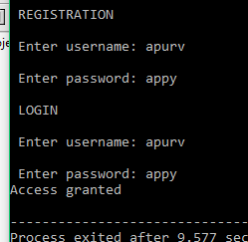

1. If username and password is not registered then

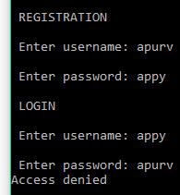

**2-Choose location:**

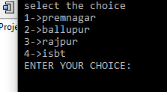

-According to choice we will ask type of lawyer

**3-Choose type of lawyer:**

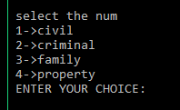

**-**According to choice we will give output

-here we are able to have an output of string as well as integer value.

**4-Data retrieval: string value as well as integer value**

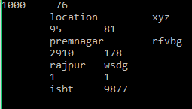

**Final Output –**

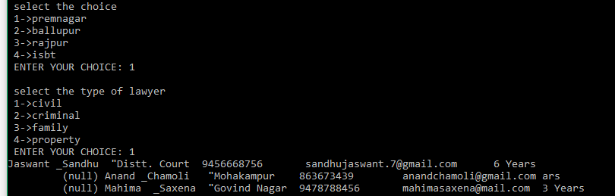Here the user chooses the location then he has to choose the type of lawyer according the need and then data is retrieved from a csv file.

**CHAPTER 6**

**RESULT**

We provided the list of list of lawyers on the basis of input given by user like his/her location and type of lawyer.

**Future Scope**

From this application a person get lawyer information from his/her nearby location according to his needs. This application can help a person anywhere , if he is in some problem through which he need lawyer to help him/her out.

**PERT CHART**

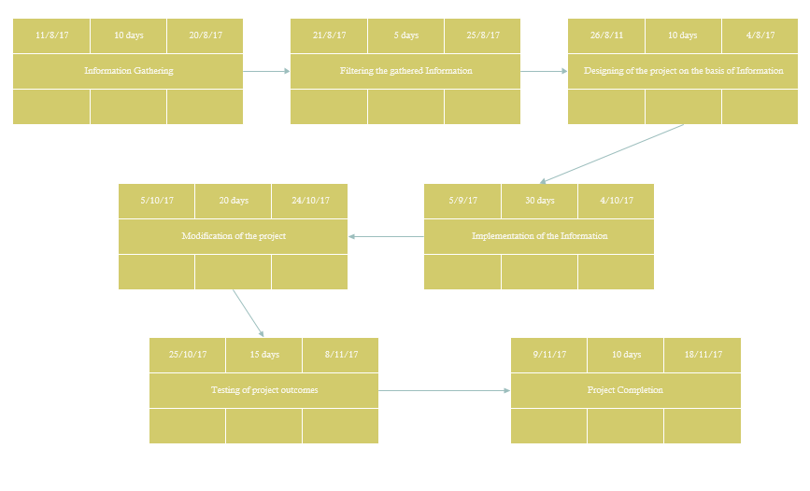

**REFERENCES**

1. <https://www.kaanoon.com/>
2. <https://lawrato.c>

**LIST OF FIGURES**

**1 FIGURE-1 xvi**

**2 FIGURE-2 xvii**

**3 FIGURE-3 xviii**

**FIGURE 1**

